**KING SOLOMON'S COLLEGE-KYATEGA**

**END OF TERM ONE EXAMINATION.2024**

**SENIOR FOUR**

**GEOGRAPHY**

**DURATION 2HOURS 45MIN.**

**INSTRUCTIONS**

Section **A** is compulsory.

Section **B** has two parts. I and II

Attempt **one** item from **each** part.

**SECTION A**

**Item 1.Map skills**

For this item, use the East Africa 1:50,000(UGANDA) map extract of Lukaya seriesY732, part of sheet79/2, edition 3USD to answer the tasks given.

a) Kyagulanyi was travelling early in the morning and met a terrorist who entered and hid himself in Road culvert at Kitokolo. He rushed and reported to counter terrorism police in Masaka and now it plans to bomb the culvert to kill the terrorist before he causes more harm to the community. But the bomb squad lacks knowledge on how to do it.

**Task.**

Advise the bomb squad on how well they can send a missile and eliminate the terrorist without destroying the whole area of Kitokolo.

b) Ssebagala a resident of Kamuwunga landing site graduated from Makerere University with bachelors of Science in Agriculture and couldn't get the job. He went back home and requested Lukaya sub county local government to allow him to clear off the papyrus swamp south of northing 85 and establish coffee plantations and animal farms. However he has faced a lot of resistance from the community on grounds that it will negatively affect the environment.

**Task.**

As secretary for environment of Lukaya local government, send an advice note to Mr. Ssebagala.

c) Komando has been living in a foreign country for the last 30 years .he plans to return to Lukaya his home area and invest his accumulated money but lacks knowledge about the opportunities for investment in the area.

**Task.**

Write to Komando advising him on what to do.

d) AVIS Uganda an international nonprofit organization based in Kampala wishes to develop infrastructures in Lukaya and conserve the environment to achieve the national development goal. However their annual budget is constrained.

But the local government of Lukaya has requested them to extend their help to upgrading of Bwesa-Nsalu motorable truck, rehabilitating Mpungwe-Nabusanke bound surface road,removing water weeds in lake Victoria, Fencing of Lwanswaswa swamp,katonga swamp as well as repairing a borehole south of Kiti .

However AVIS head office does not have the knowledge about Lukaya area.

**Task.**

As AVIS field officer based in Lukaya, help the head office to understand the areas of operation.

**Item 2.Photograph skills**

Study fig1, a photograph from one of the places in Uganda, and the text provided below it.

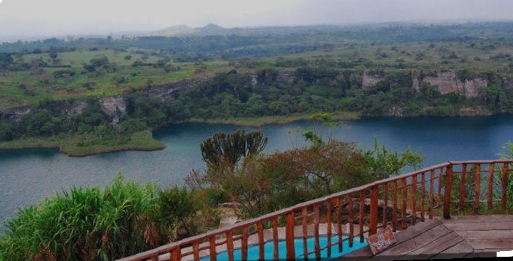

You are working with Pearl of Africa tours and Travel Company as a tour guide. A group of American tourists are planning to visit your country during their winter holiday. They booked with your company to help them tour certain areas of interest. The company manager is of the view that the tourists should visit the area shown in the photograph.

**Task.**

a) Draw a landscape sketch of the area in the photograph and on it mark and name the features found in the area.

b) Describe for the visitors the attractions they will see and activities they will engage in when they visit the area. Give evidence from the photograph.

C) Help the tourist to get informed about the challenges they are likely going to face in order to prepare for them.

d) Advise the local community on how the area can be improved for the visitors.

**SECTION B**

**Part I**

**Attempt one question from this section**

**Item 3**

. East African countries for over the years have been trying to boost trade between them and other countries. They have therefore come up with different initiatives to increase production and earnings from trade. However, despite all the efforts, earnings from exports have remained low due to subsistence production dominating in most of the East African countries.

This has worried business community and experts who have organised an economic meeting to find out the solution to the regional economic challenges.

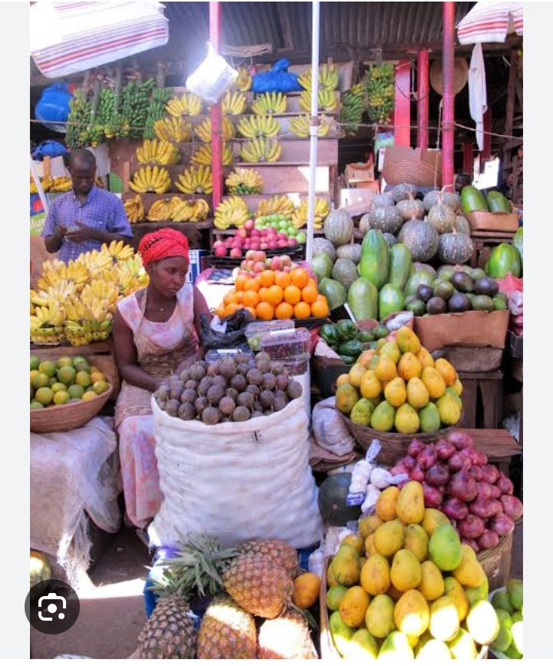Support Material

Task.

As the minister it trade from Uganda,write the speech to be presented in the meeting siting challenges associated with unfavourable balance of trade and how well the region can boost export trade.

**Item 04.**

On 11th October 2018, torrential rains caused the Tsume river in eastern Uganda’s Bududa district to burst its banks, sending large volume of water and huge boulders crashing down Mt. Elgon. The town of Bukalasi and nearby villages were worst affected. It was one of the tough choices for Uganda environmentalists on what to be done. The office of the prime minister intends to get information from the educated people with in the country especially in the field of geography on what could have been a regular contributor to the disaster in the area. The members of Bududa district also intend to find ways to deal with the problems. The meeting to discuss eastern issues is scheduled to take place at the state house Nakasero-Kampala next 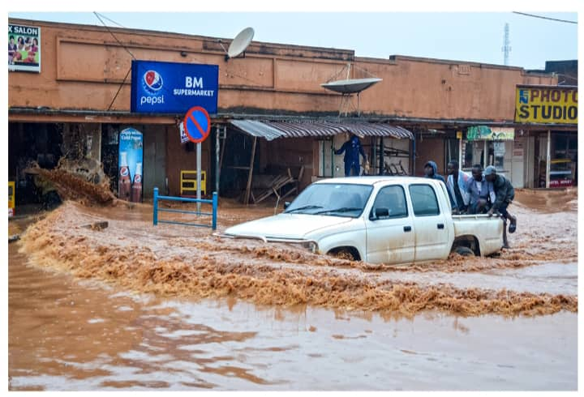month.

**SUPPORT MATERIAL.**

**TASK.**

As one of the active Participant in the fourth coming Meeting, write a speech of about 500 words to guide the house.

**Part II**

**Attempt one item from this section**

**Item 05**.

According to the 2021 Uganda population Survey, the Country’s population was estimated to be 42 million, and growing at a rate of 3% per year.

At this rate, the country is expected to reach 72.4 million people by 2040, representing an annual increase of 1.6 million people per year.

Members of your community have different views about this rate of population growth. Some see it as a benefit, while others think it is a danger to the country.

**SUPPORT MATERIAL:**

Table showing Uganda’s Population between 1980 and 2023.

|  |  |
| --- | --- |
| Year | Population (in millions) |
| 1980 | 12.6 |
| 1991 | 16.7 |
| 2002 | 24.2 |
| 2014 | 34.6 |
| 2023 | 48.6 |

Adopted: (UBOS, and Trending Economics)

**TASK.**

1. Draw a suitable graph to show the information in the table.
2. Using the information provided in the text and table, write an article of between 250-300 to be published in one of the local newspapers that will help you deal with the concerns of the Members of your community.

**Item 06.**

Mineral extraction in South Africa has a rich history that dates back to the mid-19th century. The first mine established in the region was copper project in 1952, marking the development of mining that shaped the country’s economy and society. However, having had a rich history, mining in South Africa was brought down to its knee and not heard of anymore. A few years ago, a mining company was considering a re-opening of old mine centres in Welkom, a city in South Africa’s interior. Welkom was one of the centres of the world’s richest of gold fields. There were close to 50 centres in an area roughly the size of Brooklyn, but most of these mines had been shut down in the past three decades due to varying reasons. However, the company is confused on what to be considered in the re-opening the mining centres and is planning to have a strong ways forward to the setback of the closed shafts.

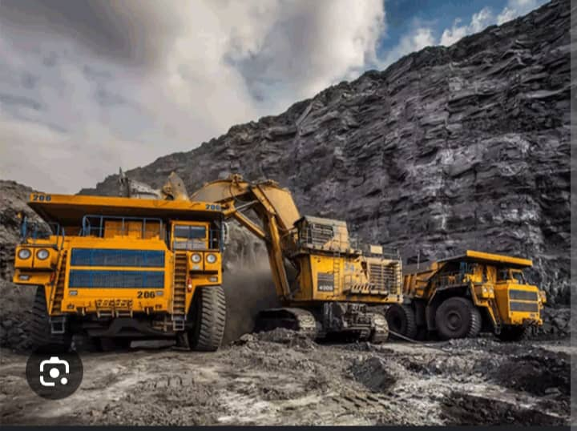**SUPPORT MATERIAL:**

**TASK.**

As a state Minister for mineral and natural resource energy in South Africa, guide the decision of the company.